**Script for the learning unit**

**Tips on image databases, screen clipping and image editing[1]**

**by Jana Eckert**

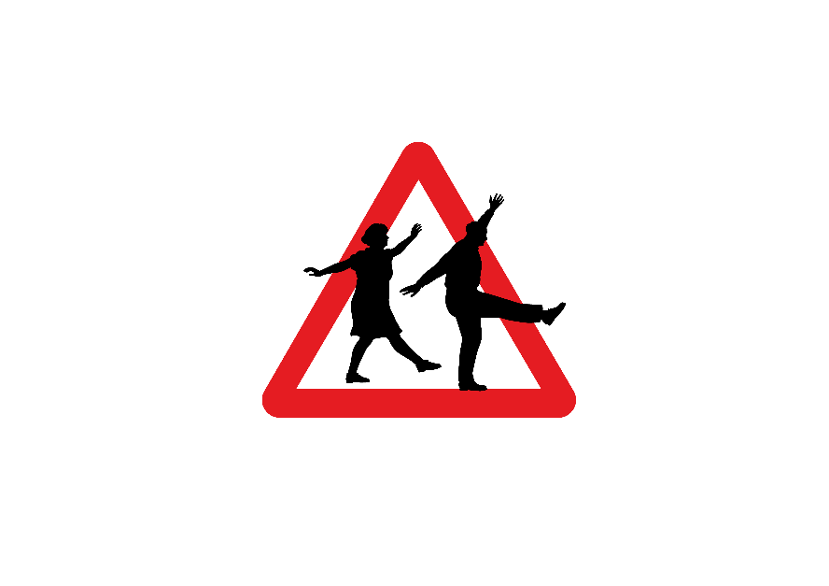

**Image databases**

**Images and graphics for flyers, posters, presentations etc. can be found in image databases, such as:**

https://pixabay.com/: Here you can find free images and graphics without registration. Pixabay also suggests images from iStock.

At iStock [(](https://www.istockphoto.com/de)https://www.istockphoto.com/) there is a very wide range of images in different price ranges (9€ or 24€ per image). However, purchasing a licence for an image can be worthwhile if you want to create very attractive material.

https://www.pexels.com/: The images can be downloaded free of charge and used, changed and edited without restriction. Registration is not necessary but is recommended for high-resolution images.

**You can find an overview of free image databases here:**

<https://www.ionos.com/digitalguide/websites/web-design/the-best-image-databases-for-free-images/>

**Image databases with positive images of older people:**

<https://ageingbetter.resourcespace.com/pages/home.php?login=true>

The pictures are free of charge, registration is not necessary but the specification of the e-mail address is required. The number of images is quite small.

<https://gesellschaftsbilder.de/> (available in German language)

https://gesellschaftsbilder.de/assets/logos/2019_02_08__09_08_00_Gesellschaftsbilder_Logo.png

The database in German language is run by the association "Sozialhelden". It offers "images far away from clichés [...]. The photo database is intended to be an offer to reflect the diversity of society. " (https://gesellschaftsbilder.de/page/%C3%9Cber%20das%20projekt)

The use of the images is free of charge, but the citation of the author is required.

**Tip:** Always save the link to the image and the licence details in a text file in the same folder in which you save the image. (In the folder right click, "new"🡪 text file)



**Create and edit a screenshot with "Snip and Sketch".**

If you want to take a sceenshot or to take a photo of a part of the screen without much effort, use "Snip and Sketch" by using the keyboard shortcut "Windows key + Shift + S".

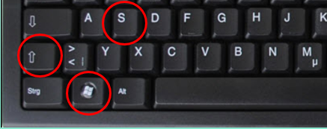

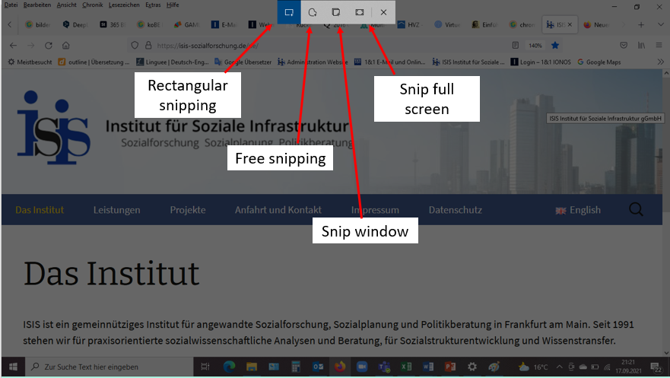**Now there are different options available: Rectangular cutting** (use the mouse to drag a rectangle around the area you want to save as a screenshot). Other options: **Free cut, Cut window, Cut full screen or Close.**

Cut window

Free cut

The image you cut is placed on the clipboard and you can paste it directly into your presentation or Word document (Ctrl + V) or you can click on the text below the image that appears at the bottom right of the screen to easily edit or save the cut.

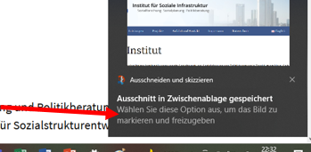

**Image editing with Paint.NET**

**“Paint.net** is a [freeware](https://en.wikipedia.org/wiki/Freeware) [raster graphics editor](https://en.wikipedia.org/wiki/Raster_graphics_editor) program for [Microsoft Windows](https://en.wikipedia.org/wiki/Microsoft_Windows), developed on the [.NET Framework](https://en.wikipedia.org/wiki/.NET_Framework). Paint.net was originally created by Rick Brewster as a [Washington State University](https://en.wikipedia.org/wiki/Washington_State_University) student project, and has evolved from a simple replacement for the [Microsoft Paint](https://en.wikipedia.org/wiki/Microsoft_Paint) program into a program for editing mainly graphics, with support for [plugins](https://en.wikipedia.org/wiki/Plugin_(computing)).”

(https://en.wikipedia.org/wiki/Paint.net)

**Important:** Only download software from sites that you know and trust. If you are not sure, find out about the provider using a search engine.



Here you can download the software Paint.net free of charge: <https://www.getpaint.net/download.html>

Useful function: **Remove background from logos and other graphics**

After you have opened a file or inserted an image, select the "Magic Wand" tool.

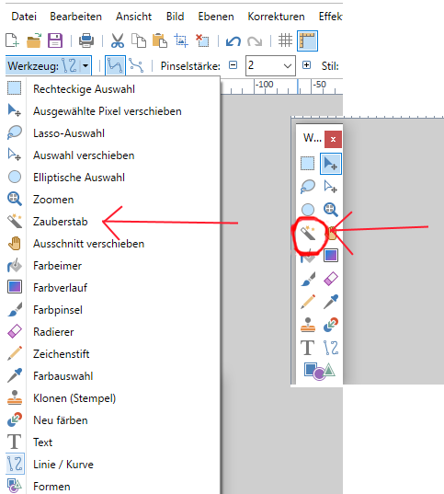

Now, select everything with the left mouse button to be removed (all together with the "Ctrl" key pressed, or for each individual area). In the menu "Edit" -> "Snip" (or: "Delete selection" or symbol ). The removed background appears as white-grey tiles. Now the graphic only has to be saved as a PNG file.

For advanced users: With a plug-in (extension), Photoshop files with several layers can also be opened.

**Further information on digital tools to create a poster**

Video tutorial basic course Microsoft Publisher: <https://www.youtube.com/watch?v=Cqo0PVhBFYI>

Alternative to MS Publisher: Video tutorial on poster creation with PowerPoint: <https://www.youtube.com/watch?v=1c9Kd_mUFDM>

**Practice:**

* If feasible, 2 persons work as a tandem with one laptop. Open MS Publisher if available (or alternatively work with PowerPoint).
* Create a poster in Din A1 (59.4 cm x 84.1 cm, in PowerPoint: draft🡪 slide size)
* Insert a text box, a graphic and/or an image (e.g. from an image database).
* Try out different functions as well as the "Snip and Sketch" app.

**About this publication**

This handout, together with the accompanying presentation of the same title, is part of the digital training developed as part of the **Bridge the Gap!** project. The curriculum was developed and tested in 2021.

Copyright (c) 2022 Jana Eckert, ISIS Institute for Social Infrastructure, gGmbH

This publication is licensed under a [Creative Commons Attribution-ShareAlike 4.0](https://creativecommons.org/licenses/by-sa/4.0/deed) International Licence (CC BYSA 4.0).



This project has been funded with support from the European Commission. This publication reflects the views only of the authors, and the Commission cannot be held responsible for any use which may be made of the information contained therein.

Ein Bild, das Text enthält.



1. Created as a handout for the learning unit on digital tools by Jana Eckert for the 3rd Bridge the Gap! workshop in Bad Vilbel on 20 September 2022.